# Running (and adding further input models)

1. To run the tool in our suggested configuration, open the **Solution** Eclipse package, use the Package Explorer to find the **Runner.java** class in the **solution** package of the **ttc16-solution** project (see Figure on the next page), right-click on this class and select “Run As -> Java Application”.

* You will see some console output. In addition, the log is persistently written to top-level folders of the **ttc-solution** project according to the names of the input models.
* In each run, the best output model is persistently written to a sub-folder in the **output_models** folder according to the input model’s name.

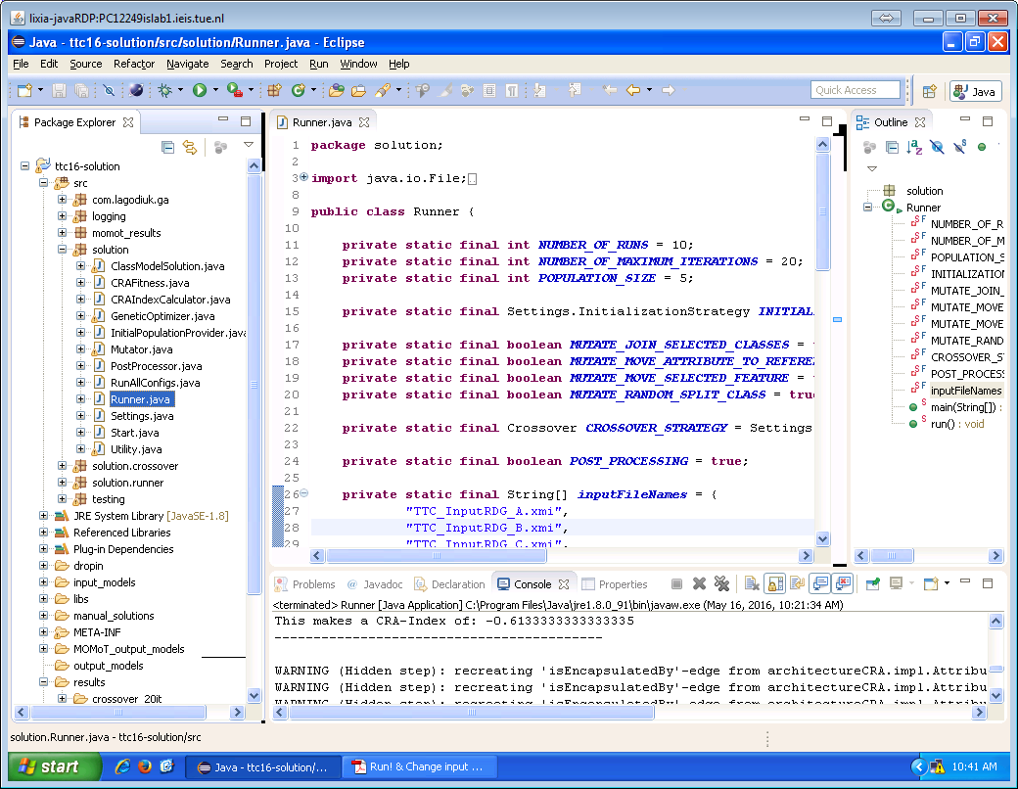

1. To run our tool on additional input model(s), copy the new model(s) to the **input_models** folder in the **ttc16-solution** project. The most convenient way to achieve this is to drag & drop the models.  
     
   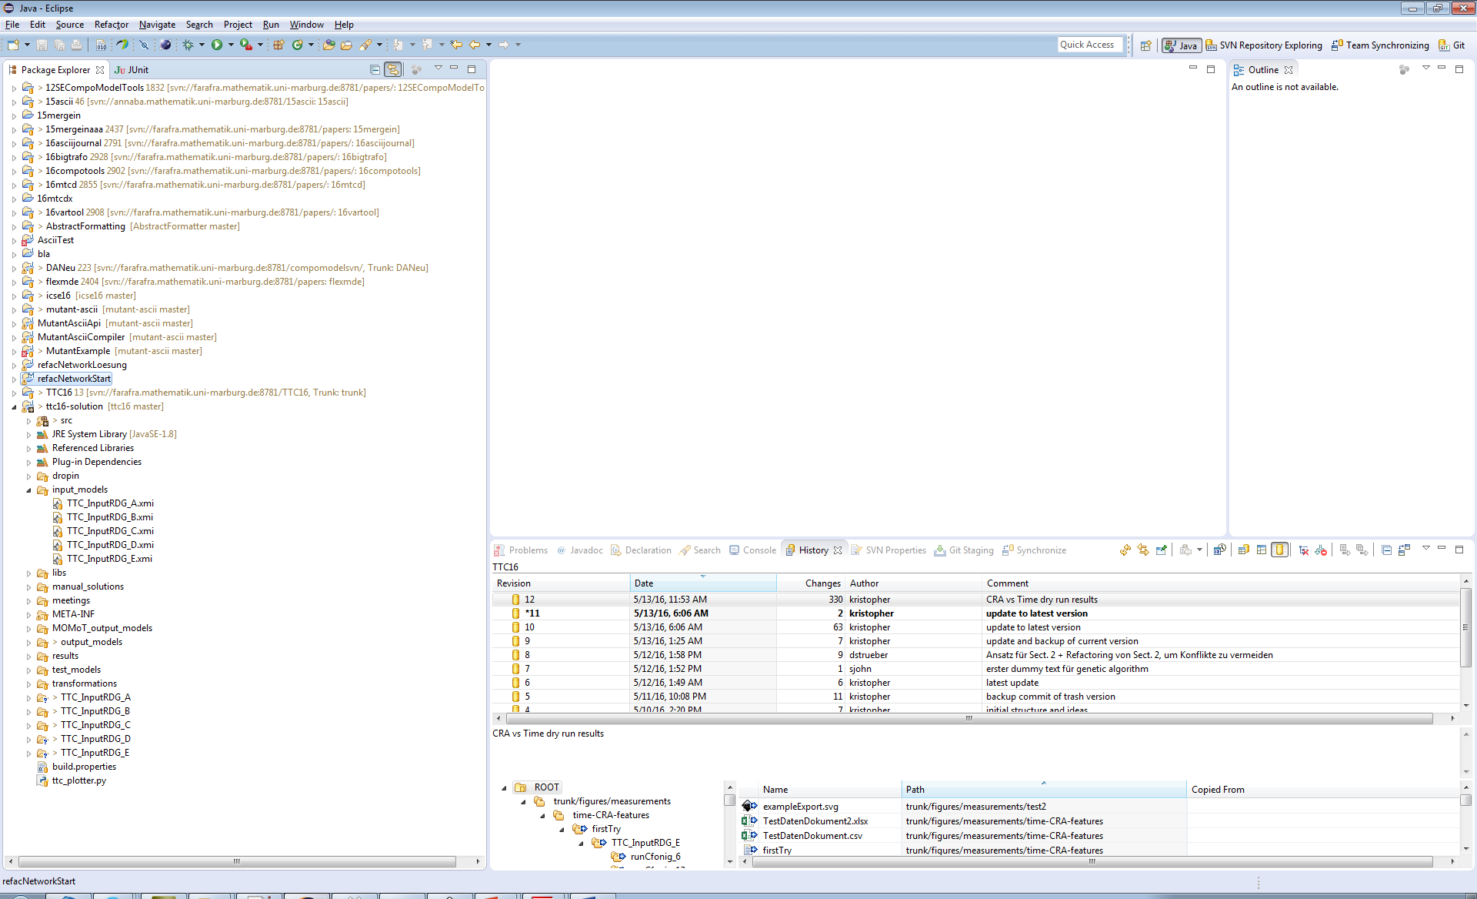

**Drag and drop here**

1. Now adjust the **inputFileNames** field in the **Runner** class in the **solution** package of the **ttc16-solution** project (see next Figure) and go back to step 1. 